Soft-Wired: How the New Science of Brain Plasticity Can Change Your Life
Author:
Michael Merzenich, PhD

Book Topics:
Alzheimer's
Auditory impairments
Autism
Brain injuries
Brain plasticity
Brain training
Cutting-edge research
Depression
Efficiency and productivity
Intelligence
Memory
Mental illness
Neuroscience
Parkinson's
Schizophrenia
The aging brain
True-life stories
Visual impairments
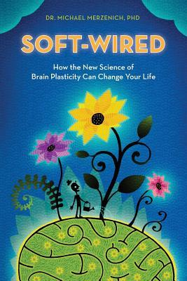

The Brain That Changes Itself: Stories of Personal Triumph from the Frontiers of Brain Science
Author:
Norman Doidge, PhD

Book Topics:
Brain plasticity
Brain training
Cutting-edge research
Intelligence
Memory
Mental illness
Neuroscience
True-life stories
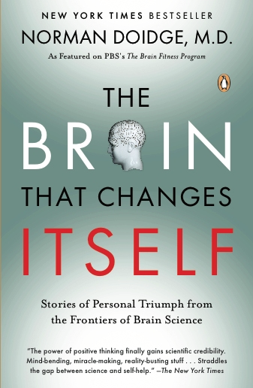

Coming of Age on Zoloft: How Antidepressants Cheered Us Up, Let Us Down, and Changed Who We Are
Author:
Katherine Sharpe

Book Topics:
Anxiety
Depression
Drugs
True-life stories
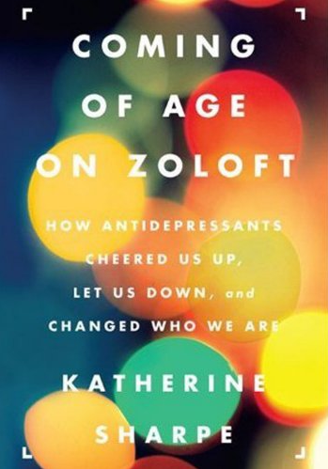

Brainstorm: The Power and Purpose of the Teenage Brain
Author:
Daniel Siegel

Book Topics:
Brain plasticity
Children and teens
Cutting-edge research
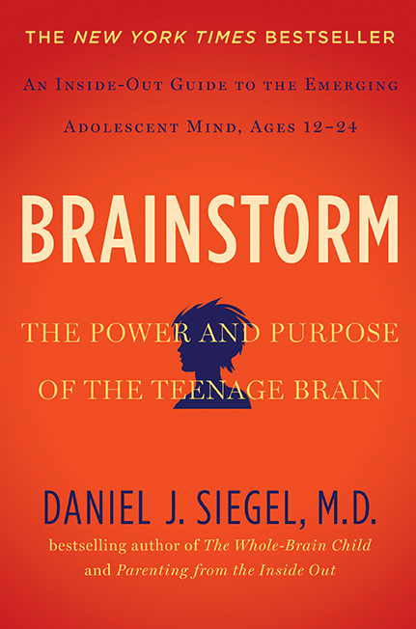

Brain Bugs: How the Brain’s Flaws Shape Our Lives
Author:
Dean Buonomano, PhD

Book Topics:
Cutting-edge research
Neuroscience
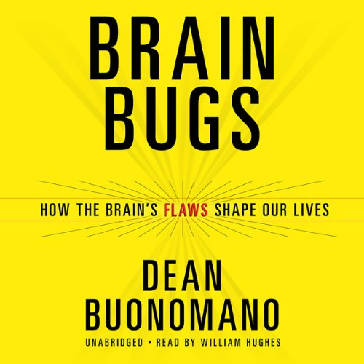

A Calm Brain: How to Relax into a Stress-Free, High-Powered Life
Author:
Gayatri Devi, M.D.

Book Topics:
Anxiety
Efficiency and productivity
Sleep and the brain
Stress
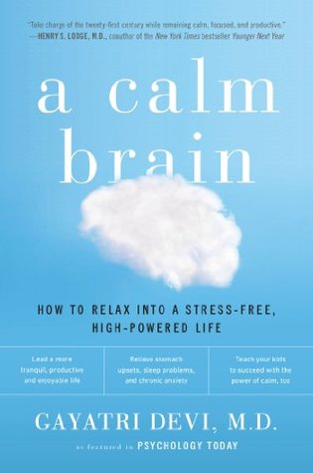

30 Lessons in Living: Tried and True Advice from the Wisest Americans
Author:
Karl Pillemer, PhD

Book Topics:
The aging brain
True-life stories

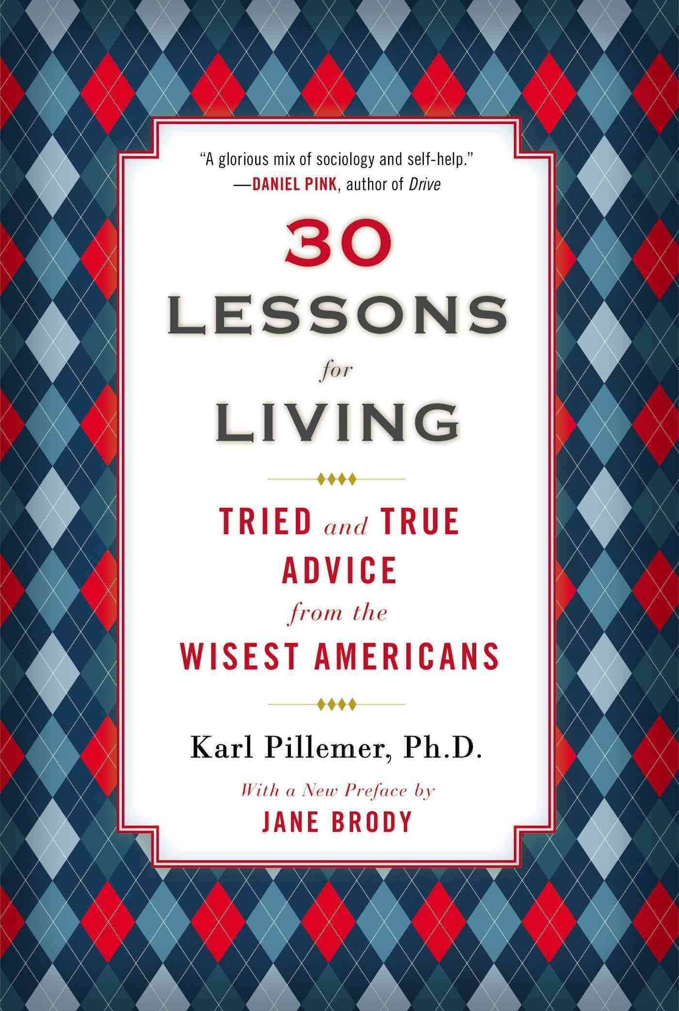
100 Plus: How the Coming Age of Longevity Will Change Everything, From Careers and Relationships to Family and Faith
Author:
Sonia Arrison

Book Topics:
The aging brain
